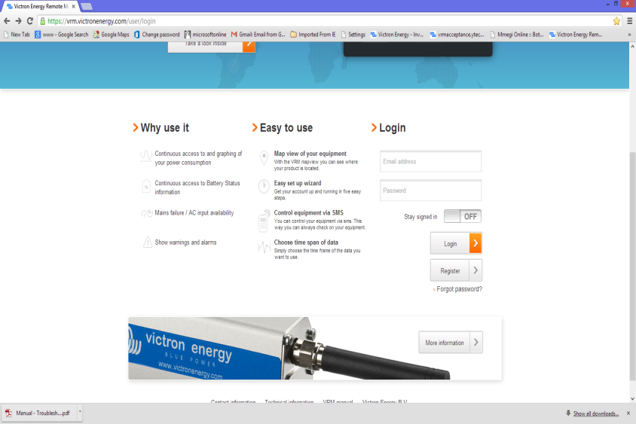
Click on Register

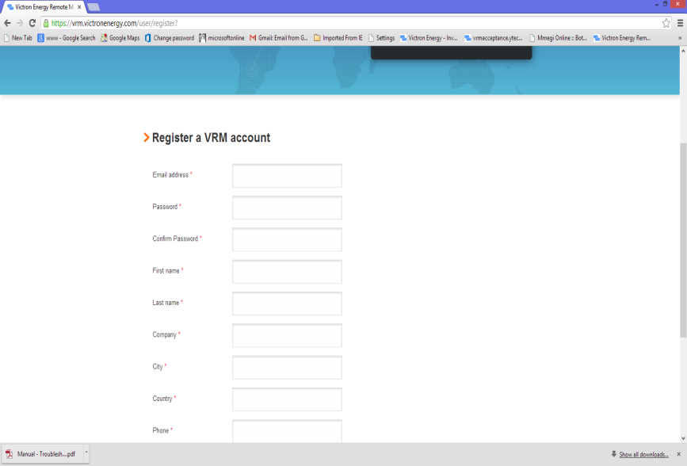
Complete all the requested information

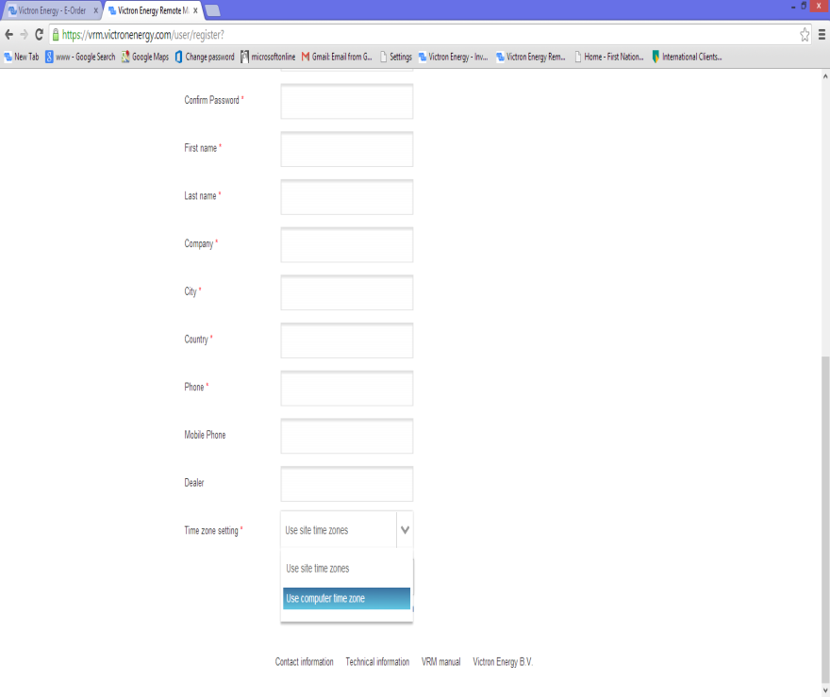

To ensure accurate logging in the graphs according to time, it is best to select ‘Use computer time zone’ when asked for a time zone setting, this will ensure where ever you are when looking at the site the date and time is accurate

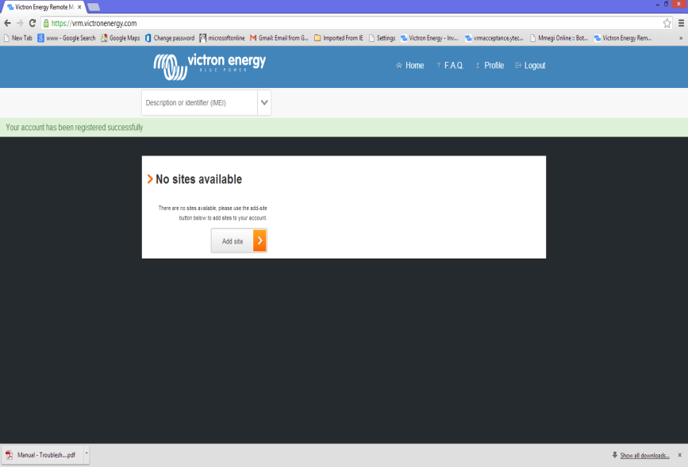
Now at this screen you have to select Add site to add your first site.

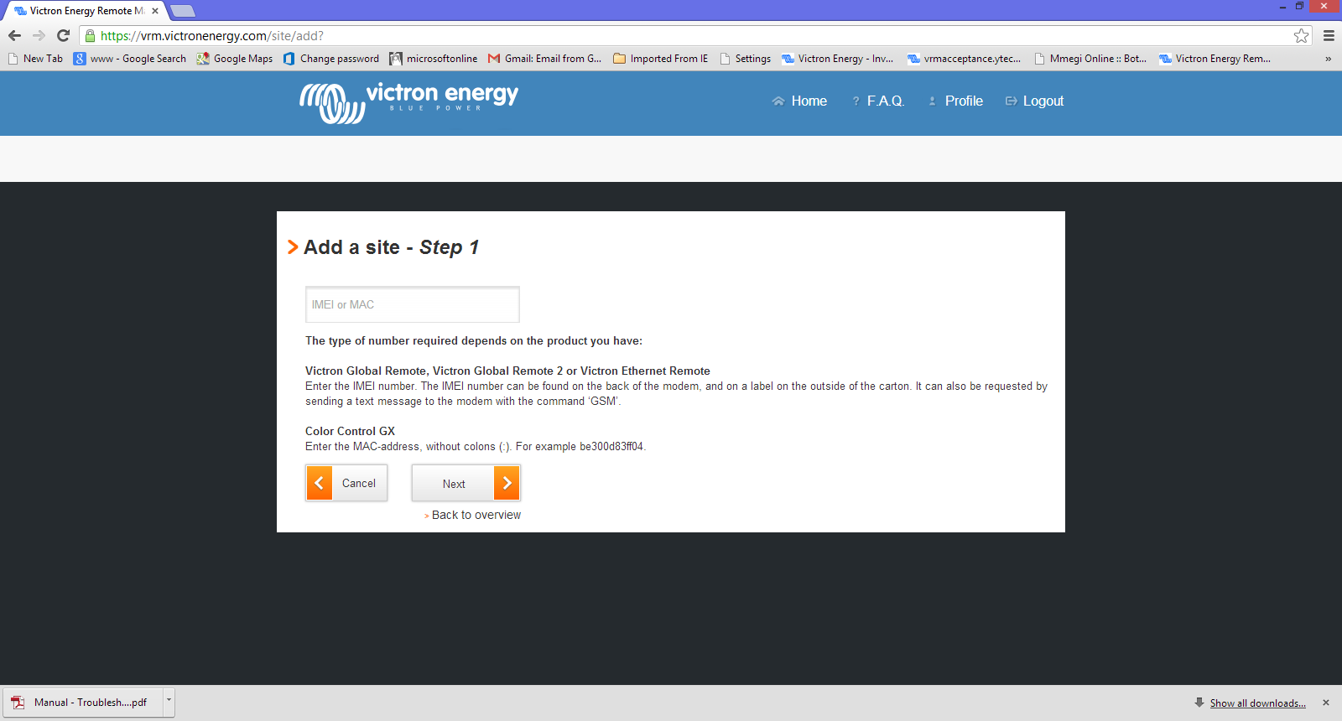

Once you have an IMEI or Mac Address number for one of the VGR, VER or CCGX product,
Enter your number, click next and your device is now linked to the site.

Once the Device is linked to the site, the device needs to be set up, for VGR with a Sim card at first only SMS functionality is possible, this means the Logging feature is not active. In the manual, which must be downloaded from the website, it is explained how to set up/switch on the GPRS mode, this mode, GPRS is used for Data Logging. It can be set up using SMS communication or by using the USB cable supplied, the USB Mode should be done in an office environment with a PC with the software installed, do not try and do this on site as it can take up to 30 minutes to install the software!

